**Defect Report**

* **Defect Id: 6**
* **Status: New**
* **Reported by: Bishoy**
* **Date:**  **13/5/2023**
* **Defect description: after entering the student id = "s1900733", an** *INVALID_STUDENT_ID_DOES_NOT_START_WITH_NUMBERS* **exception must be thrown but nothing was thrown, and the student id was stored normally.**
* **Steps:**

1. **Open the application**
2. **Enter the student id = “s1900733”**
3. **Run the program**

* **Fixed By: Malek**
* **Severity: Low**
* **Priority: High**
* **Screenshot for the Defect:**

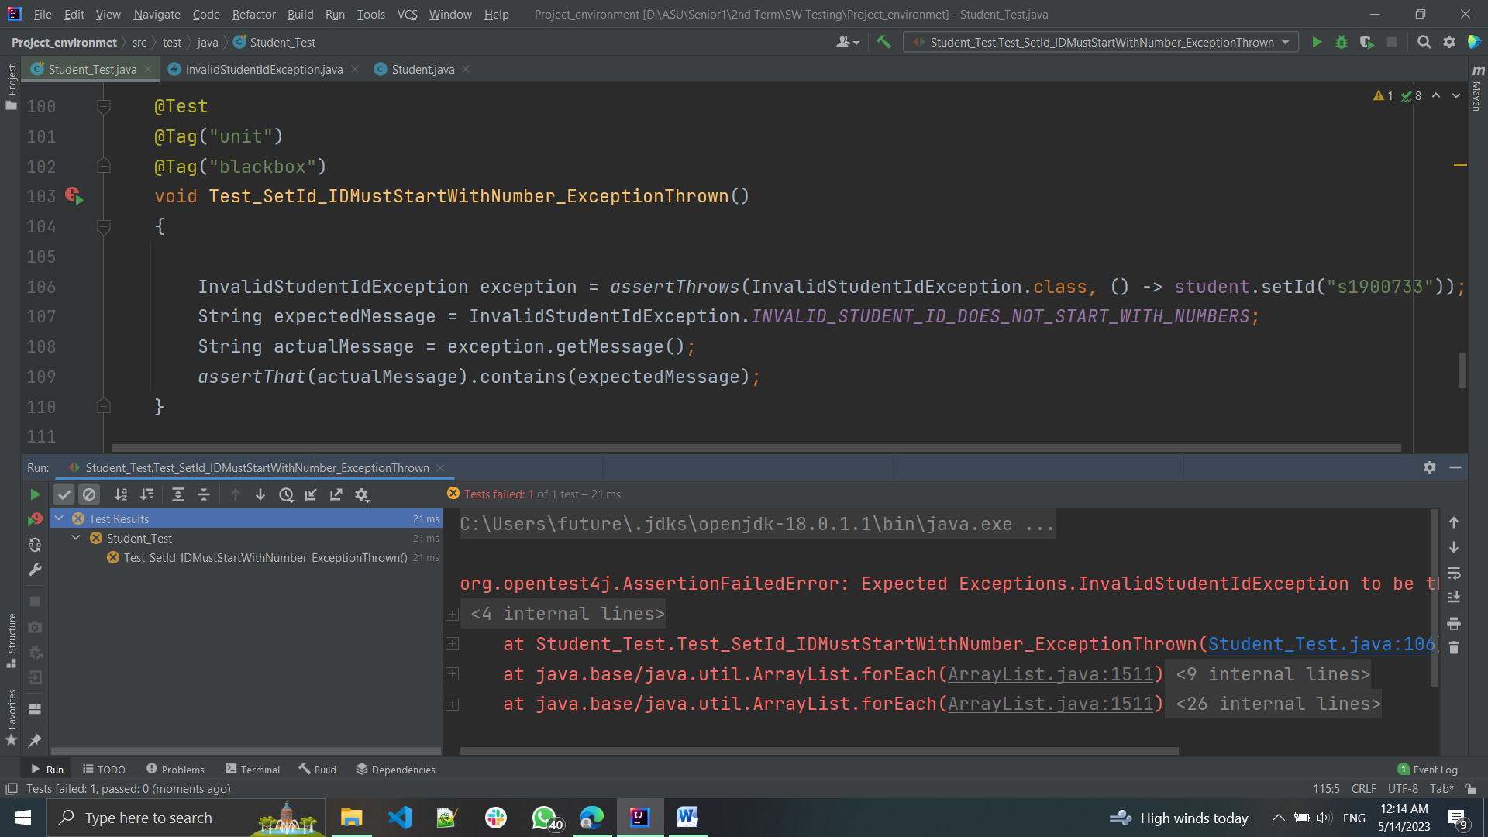

* **Screenshot after fixing:**